DCR Graph

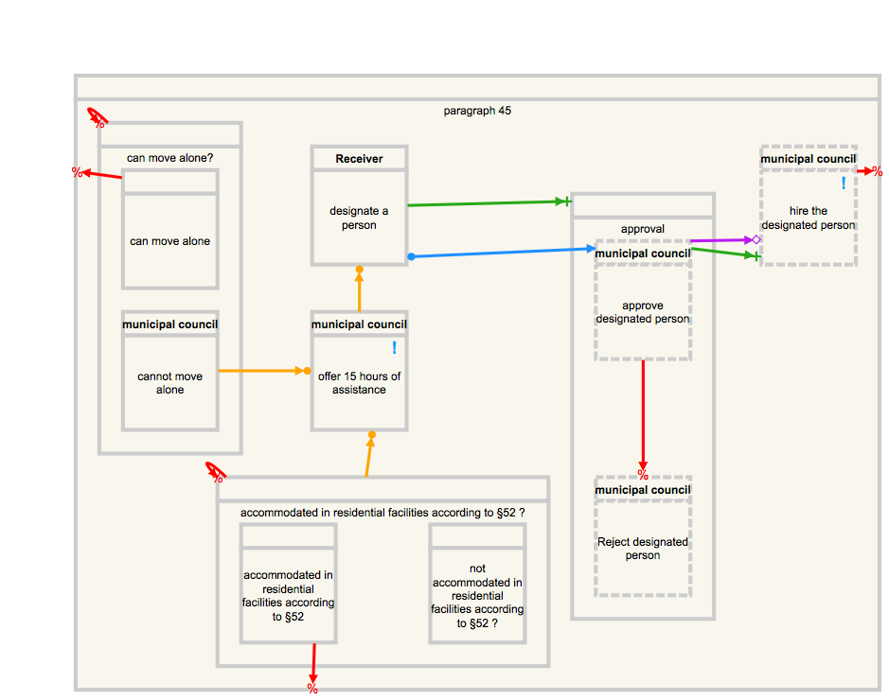
Figur 1: DCR graph modeling Section 45 of Consolidation Act on Social Services. cf. http://english.sm.dk/media/14900/consolidation-act-on-social-services.pdf

Comprehension Questions

Question 1:

The appointed person can be hired by the municipal council without the approval of the municipal council. True or False?
Question 2:
When the municipal council offers 15 hours part-time assistance, then it is mandatory for the receiver to designate a person. True or False?
Question 3:
Consider a 15 years old young person who is not accommodated in residential facilities (according to § 52) and whose freedom of movement is impeded due temporal impairment of physical function. Will the municipal council offer 15 hours assistance?
Question 4:
If the receiver designates their mother, can the municipal council approve the designation?
Question 5:
Assume that the municipal council determined that a young person cannot move alone, and the person is accommodated in residential facilities, can the municipal council offer 15 hours of assistance to that person?
Question 6:
Assume that the municipal council determined that a young person cannot move alone, and the person is not accommodated in residential facilities. Then, the municipal council offered 15 hours assistance, and the receiver designated a person to assist him. Afterwards, the municipal council has rejected the designated person. Can the receiver designate a new person again?

Think-Aloud Questions

- How and for what purpose did you use the following artifacts: model, law text, simulator?

- Thinking about the overall experiment, was there anything challenging?

