Question 2 (constraint task)

Question Text:
When the municipal council offers 15 hours part-time assistance, then it is mandatory for the receiver to designate a person. True or False?
Scarf-Plots:
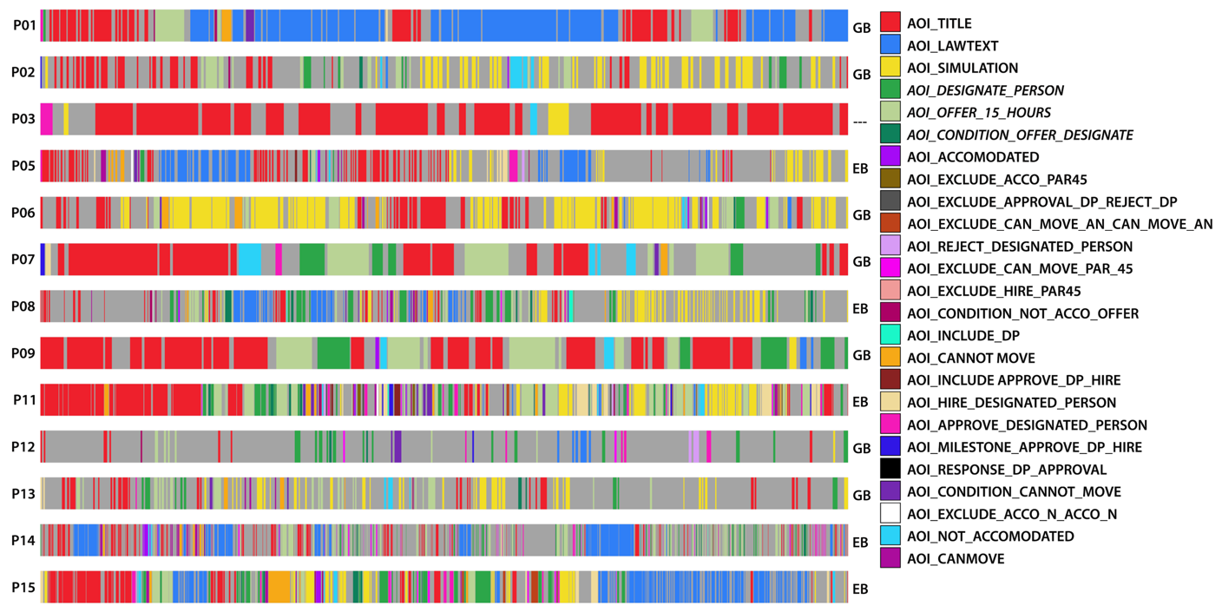
Qualitative coding of scarf-plots:
P01. Seems to have a goal-directed behavior as he looks at the relevant AOIs in the graph after checking the title, but he mostly uses the law text (81.42% of the overall ‘fixation on AOI time’). Looks like the person know what to look for, but does not understand the model. Never uses simulation. He fixates constraints.
P02. Seems to have a goal-directed behavior as he looks at the relevant AOIs in the graph after having checked the title. However he also looks at neighboring areas from time to time, mostly constraints. He then uses simulation towards the end of the task, probably to validate the answer. He never fixates constraints.
P03. This participant only looks at the title. He takes much less for this task compared to other tasks.
P05. This participant is a good example of exploratory behavior. He looks several times in the graph but without focusing on any specific AOI (AOI_approve_designated_person, AOI_hire_designated_person, AOI_cannot_move and AOI_canmove were the most fixated AOIs, but he fixated 15 different AOIs overall). Then, he seems to use the law text to understand the model, as he switches between title, graph and law text a few times. Then, he uses simulation in the end, probably to validate his answer. He fixates constraints. He claims to have used the simulator as an exclusion criteria, only twice throughout the experiment.
P06. This participant heavily relied on simulation for both understanding the model and validating his answer. He has a goal-directed behavior as he focuses on the relevant AOIs of the graph in-between the simulation. He fixates constraints.
P07. This participant seems to have a goal-directed behavior as he mostly focuses on relevant AOIs (33,99% of the overall fixation on AOI time is spent on the relevant ones and he fixates few AOIs in the graph overall). However, he seems to look at some other areas of the graph (especially towards the end of the task) to validate his answer. He never uses the law text or the simulation. He fixates constraints.
Insights from the video: Towards the end of the task P7 seems to often look away (bottom of the screen). The non relevant areas he fixates are all in the lower part of the graph, so they are probably just looked at by chance.
P08. This participant has an exploratory behavior of a person that knows how to read a DCR. Indeed, he observes 15 AOIs in the graph and focuses on the constraints surrounding the relevant AOIs very carefully. He uses the law text while reading the graph (probably to improve graph understanding). He spends 30.70% of the overall fixation on AOI time on the relevant AOIs and seems to use simulation at the end to validate his answer.
Insights from the video: P8 simulates all the areas in the graph that are somehow related to activities “offer_15_hours” and “designate_person”. He seems to read very carefully.
P09. This participant is a good example of goal-directed behavior (only looks at 5 AOIs in the graph) as he moves from the title directly to the relevant AOIs, where he spends spends 35,31% of the overall fixation on AOI time. He goes back from the title to the AOIs a few times. In the end he uses both the law text and the simulation for a short amount of time, probably for validating his answer. He never fixates constraints.
P11. This participant shows an exploratory behavior, although he spends the 28.34% of the overall fixation on AOI time on the relevant areas. Indeed, he fixates many AOIs in the graph. He seems to use simulation at the end to validate his answer. He fixates constraints. In the think aloud he mentions having fixated the model for a long time at the beginning of the experiment, to be able to memorize the information needed also for the next phases.
P12. The behavior seems to be goal-directed, as the main focus is on relevant AOIs. However, towards the end of the task, he focuses on other AOIs in the graph and on the law text, probably to confirm his answer.
P13. The participant seems to have a goal-directed behavior, as he fixates the relevant AOIs right after having read the title and spends the 31.42% of his overall fixation on AOI time there. He seems to use simulation while reading the model, probably for both understanding and validation purposes. He fixates constraints.
P14. This participant has an exploratory behavior, as he moves to the law text after having read the title and then moves to the graph where he fixates 16 different areas. He uses the law text throughout the whole task, probably for understanding the model. He fixates constraints. In the think aloud he confirms having used the law text and also the simulator when he had troubles understanding what the question was asking.
P15. This participant shows an exploratory behavior as he fixates 18 different areas of the graph including the relevant AOIs, where he spends 21.01% of his of the overall ‘fixation on AOI time’). He uses both the law text and the simulation both at the beginning and at the end part of the task, probably for understanding the model but also for validating his answer. He fixates constraints. In the think aloud he mentions using the simulator for confirming his answers. He claims that the law text provides more details that are not captured by the model.

Question 3 (decision task)

Question Text: Consider a 15 years old young person who is not accommodated in residential facilities (according to § 52) and whose freedom of movement is impeded due temporal impairment of physical function. Will the municipal council offer 15 hours assistance?

Scarf-Plots:
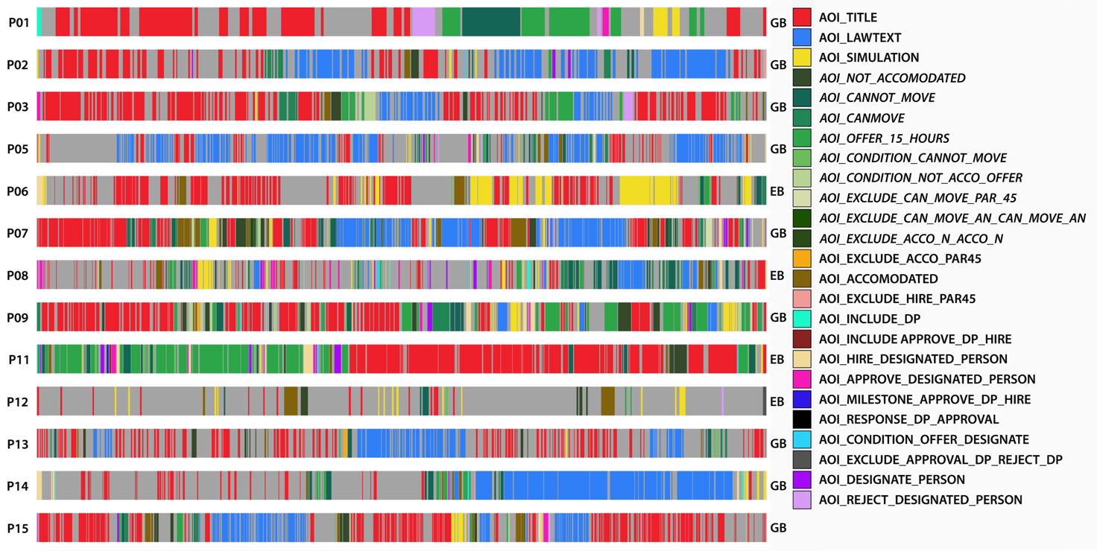
Qualitative coding of scarf-plots:
P01. This participant seems to have a goal-directed behavior. The participant spent a relatively long period of time reading the title, then shortly (i.e, after visiting only one none-relevant AOI), the participant started moving from one relevant AOI in the model to another. No fixations on relations. No fixations on the law text. Few fixations on the simulation but no interactions (video). None-relevant AOIs very shortly fixated by the end of the trial. Two relevant AOIs are mostly fixated “cannot move alone” and “offer 15 hours”. He fixates relevant AOIs for the 35.17% of the time while spending only the 8.86% of the time on non-relevant ones.

P02. This participant seems to have a goal-directed behavior. The participant started reading the title, then fixated one of the relevant AOI in the model and then looked at the whole law text (video), afterwards the participant hovered on the two activities which could potentially comprise the law fragment allowing to answer the question (video) and read the corresponding law fragments. No interactions with the simulation (video). By looking at the database, he seems to use the model only as an access point for reading the law text.

P03. This participant seems to have a goal-directed behavior. The participant started reading the title, moved to the relevant AOIs (2 most relevant activities: can move alone, cannot move alone) in the model, then moved back to the title, and moved to a potentially relevant and a relevant AOIs (accommodated, not accommodated) successively. The participant also fixated a relevant constraint (condition not accommodated, offer 15 hours). Afterwards, the participant reads the question title, then hovered a relevant activity, read the associated textual fragment and did the same for another relevant activity (video). The identification of the relevant activities seem to be goal-directed, while the identification of the target law fragment in the relevant AOI seem to be exploratory. No interactions with the simulation (video)

P05. This participant seems to have a goal-directed behavior. During the first half the trial, the participant is switching between the title and the whole law text (video). In the second half, the participant follows two patterns: (1) first the participant uses an exploratory approach looking in different AOIs for short periods of times without specific focus (2) by the end of the session, the participant goes back to a goal-directed approach where he/she is fixating the relevant AOIs, hovering them and reading the corresponding law text before again seeing the law text as a whole (video). No interactions with the simulation (video) can we check that with video. P5 fixates relevant AOIs for the 5.12% of the time and non-relevant ones for the 3.26 %: the use of the graph is definitely exploratory.

P06. This participant seems to have an exploratory behavior. The participant did not fixate the law text at all and relied mainly on the simulation.

P07. This participant seems to have a goal-directed behavior. During the first 40% of the trial, the participant is mainly intertwining between the title and the relevant AOIs in the model including those about activities and those about relations. In some parts the relevant AOIs were visited successively. In identifying the relevant activities and relations, the participant seems to follow a goal-directed approach by looking only at the relevant AOIs. From 40% to 70% of the trial, the participant start hovering the relevant activities and read their corresponding law fragment, which suggest that the participant followed an exploratory approach to identity the target law fragment in the relevant AOIs. At 70% the participant read the whole law text. Afterwards, the participant fixated mostly the relevant AOIs in the graph, before having short looks everywhere in the model. No simulation used (video). The participant seems to read to the whole law text just for validation because in the video the participant has fixated the word “permanent” in the law fragment associated with the activity “cannot move alone” and then fixated the word “permanent” in the question text, which suggest that at point the participant got an idea about the answer (video).

P08. This participant seems to have an exploratory behavior. During the first 70% of the trial, the participant is looking at different non-relevant AOIs in the graph for short timespans without really focusing on a specific one and referring from time to time to the question text. In the last 30% the participant seems to identify the relevant AOIs, hovering it, and reading the corresponding law fragment (video). No simulation used (video)

P09. This participant seems to have a goal-directed behavior. During the first 60% of the trial, the participant intertwines between the question text and the relevant AOI. In several occasions the participant fixates relevant AOI (activities and relations) successively. The participant hovered one activity but had only very short looks at the law text (video). The video shows that the participant did not focus on law text. No simulation used (video)

P11. This participant seems to have an exploratory behavior. The participant spent the first 40% of the trial inspecting the modeling without reading the question. Afterwards, spent a considerable amount of the remaining time looking at the question and shortly looking at the relevant AOIs without focusing on them, which suggest an exploratory behavior. The participant did not fixate law text. No simulation used (video)

P12. This participant seems to have an exploratory behavior. The participant has few fixations, was looking all over the graph. The participant did not fixate the law text. No simulated used (video). By looking at the database, we observed that he focuses mostly on relevant AOIs.

P13. This participant seems to have a goal-directed behavior. The participant intertwined mainly between the question text and the whole law text (video). The participant had few fixations on the model but did not focus much on it.

P14. This participant seems to have a goal-directed behavior. During the first 60% of the trial, the participant read the question text and then fixated the relevant AOIs successively (only activities). During the rest of the trial the participant has mainly read the whole law text (video).

P15. This participant seems to have a goal-directed behavior. The participant intertwined mainly between the question title and the whole law text (video). At beginning of the trial, we could briefly see the participant was fixating the relevant AOIs in the graph successively, but these fixations were a bit short.

Question 5 (scenario task)

Question Text: Assume that the municipal council determined that a young person cannot move alone, and the person is accommodated in residential facilities, can the municipal council offer 15 hours of assistance to that person?
Scarf-Plots:
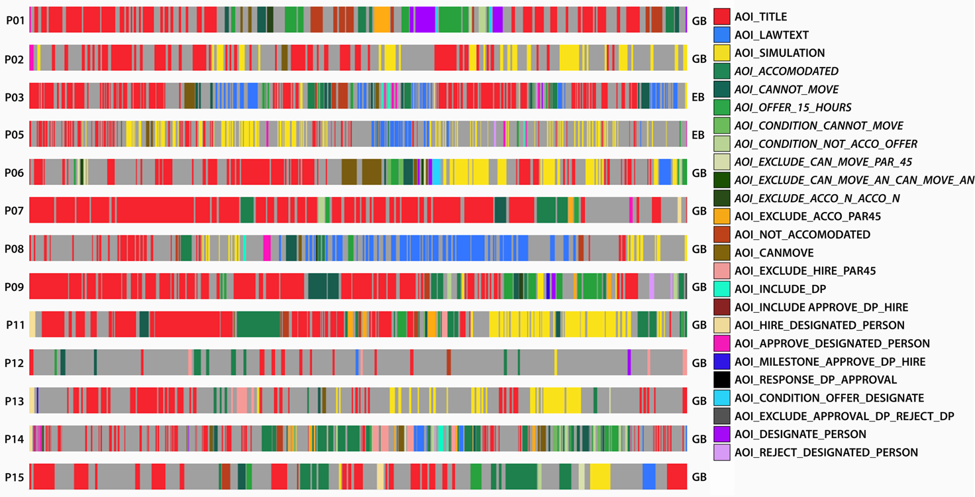
Qualitative coding of scarf-plots:
P01. This participant shows a goal-directed strategy based solely on observing the graph. From the title he moves to the relevant AOIs in the graph and jumps from one to the other looking also at proximal, relevant constraints. He returns to the title only once (towards the end of the task), before going to relevant AOIs of the graph again. He never uses the law text nor the simulation.

P02. This participant exhibits a goal-directed strategy based only on the use of simulation. He only fixates the graph once, after having initiated the simulation and in a partially relevant area. He never uses the law text, nor fixates constraints. Video insights: P2 uses only the simulation to respond to the question, starting from the first AOI mentioned in the question title and proceeding with the second one mentioned there. He simulates only once.

P03. This participant seems to have an exploratory behavior since, after having read the title, he moves to partially relevant AOIs in the graph, but quickly switches to the law text (the areas in the graph he looks at before moving to the law text are not associated to the portion of the latter containing the answer). After having looked at the law text, goes back to the graph and the title several times. In the graph, he mostly looks at relevant or partially relevant areas, but also looks at the highest portion of the graph and glimpses on simulation a few times. He fixates constraints. Video insights: P3 reads the law text only once, focusing on the law text associated to AOI_cannot_move (i.e., not the one containing the answer). Then she jumps from the title (also from end to beginning of the latter) to the graph several times, as if he is not understanding something.

P05. This participant exhibits a behavior that seems to be exploratory as he mostly uses the simulation, but also reads the law text at some point, looking both at relevant and non relevant areas of the graph for a little amount of time. He fixates some constraints. Video insights: P5 starts from enacting the simulation from AOI_cannot_move and completes the simulation correctly in the very first part of the task. Then he seems to look around law text and shows very long saccades to other areas of the graph as if he didn’t know where to find the answer. He looks at the simulation,but does not use it anymore. He also takes a long to answer and reads the title of the question several times before providing an answer.
From the think aloud he mentions having used the graph a lot but the graph itself was more confusing than helping.

P06. This participant shows a goal-directed behavior by combining the use of the graph and the simulation. After having read the title for quite some time, he starts by looking at the graph, fixating relevant and partially relevant AOIs. Then he runs the simulation, probably for validating his answer. In the end, he seems to also focus on the law text. Video insights: P6 runs the simulation on the relevant AOIs (cannot move and accommodated). He does not really read the law text. It’s mostly a look-away.

P07. This participant shows a goal-directed behavior, focusing solely on the graph. He fixates only the relevant areas in the graph, going back to the title a few times. He fixates constraints, especially the critical one needed to respond to the question.

P08. Following the title, this participant starts by looking at the graph focusing on relevant AOIs mentioned in the title. However, he soon switches to the simulation and then spends most of the time on the law text, going back to the title and the simulation just before the end of the task. He fixates constraints. Video insights: the user does not run the simulation (these gazes can be classified as look aways). He reads the whole law text.

P09. This participant exhibits a goal-directed behavior based mostly on the use of the graph where he mostly fixates relevant areas. He switches from the graph to the title and fixates relevant constraints. He has a few glimpses on simulation, but they are probably due to look-aways as he does not seem to use the simulation. Video insights: P9 does not run the simulation.

P11. This participant seems to have a goal-directed behavior as, after having read the title he starts by looking at relevant AOIs in the graph. He fixates almost all the AOIs needed to answer the question, including constraints. He switches between the title and the graph, but also moves from one relevant AOI in the graph to another. In the end he uses the simulation, probably for validating his answer. Video insights: P11 runs the simulation after having checked the relevant areas of the graph. From the think aloud he mentions having used the simulator to confirm the answers he had in mind after having looked at the model. Indeed, according to the participant, the simulator was useful to show the behavior of constraints and to improve understanding of the model throughout the experiment.

P12. This participant exhibits a goal-directed behavior, mostly based on the use of the graph. Indeed, he looks at relevant areas of the graph going back to the title a few times. In the end, he glimpses on simulation, but the fixation is too short (83 milliseconds) to think that he has actually used it.

P13. This participant seems to be goal-directed, although he/she to start in a more exploratory way, as he fixates a couple of AOIs in the graph before switching to the title again and resorting to simulation. He switches between simulation and the title a few times, also going quickly back to relevant AOIs in the graph. Video insights: P13 runs the simulation and seems to get the answer from it. The looks at the graph are mostly done when reading the title.

P14. This participant seems to have a goal-directed behavior, based on the use of the graph. Indeed, after having read the title he focuses on relevant AOIs in the graph and moves from one AOI to the other, going back to the title only a couple of times for a very short amount of time. Apart from a quick look at the law text (around two seconds), he remains on the relevant AOIs of the graph until the end of the task, concluding by reading the title, tends to triangulate, i.e., follows constraints in the graph connecting relevant AOIs. He only glimpses 98 milliseconds on the simulation.

P15. This participant seems to have a goal-directed behavior, as after reading the title he focuses on relevant AOIs in the graph, going frequently back to the title. He reads constraints. Towards the end of the task he has a couple of glimpses on law text and simulation but seem to be too short to state that he really used them. Video insights: He does not read the law text, nor uses the simulation.

